**Lesson 09 Demo 03**

**Creating a Next.js Routing Application**

**Objective:** To create the Next.js server-side routing application based on the path provided by the browser

**Tools required:** Node.js and React.js

**Prerequisites:** None

Steps to be followed:

1. Create and set up a Next.js project
2. Create components for routing
3. Run the application

**Step 1: Create and set up a Next.js project**

1. Open a terminal window to run the following command to create a **next-js-routing-app** project:

**npx create-react-app next-js-routing-app**

1. Open the created React app folder (**next-js-routing-app**) in VS Code by clicking on **File** in the top left corner and selecting **Open Folder**

1. Select the **next-js-routing-app** folder and click on **Open** button

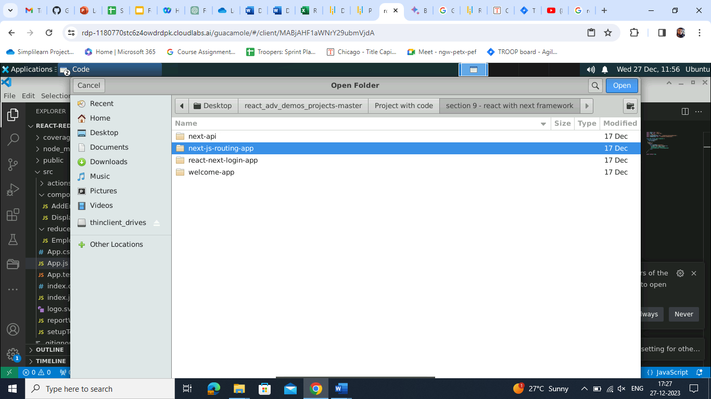

The folder structure appears as follows:

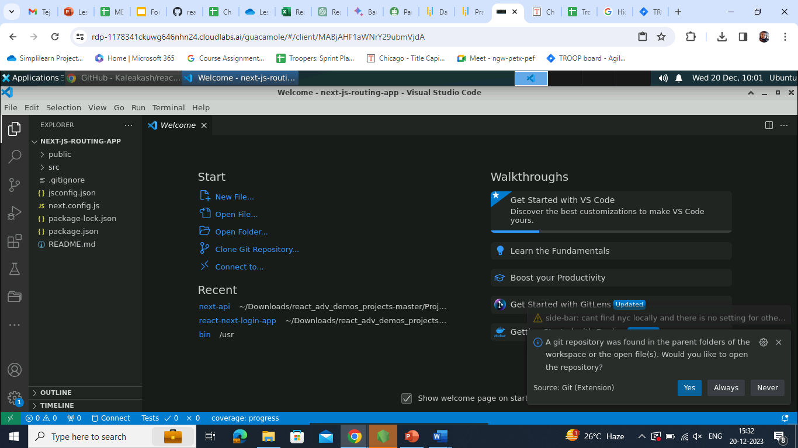

1. Open the **TERMINAL** inside the **next-js-routing-app** folder

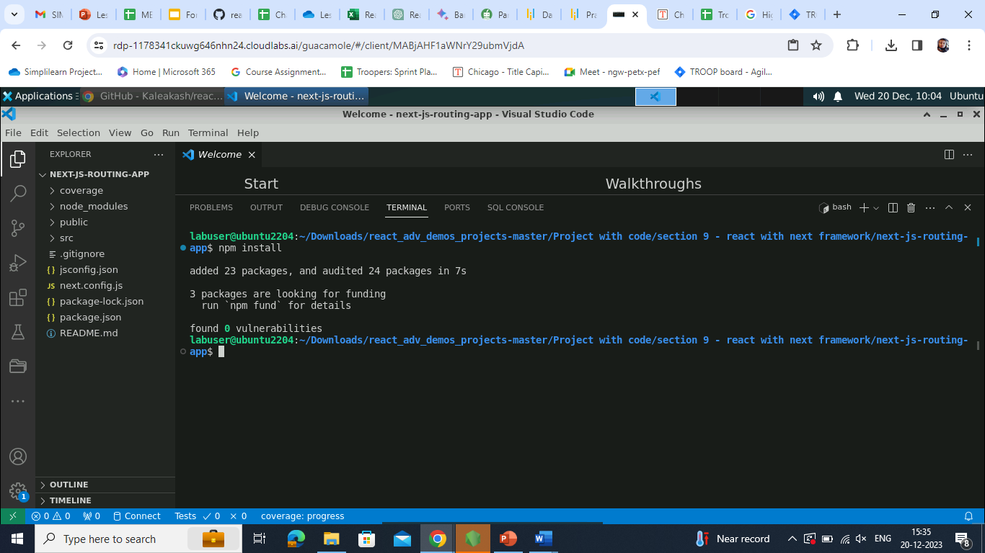

**Step 2: Create components for routing**

1. Within the **src/app** folder, create an **about** folder and then create a **page.js** file inside it

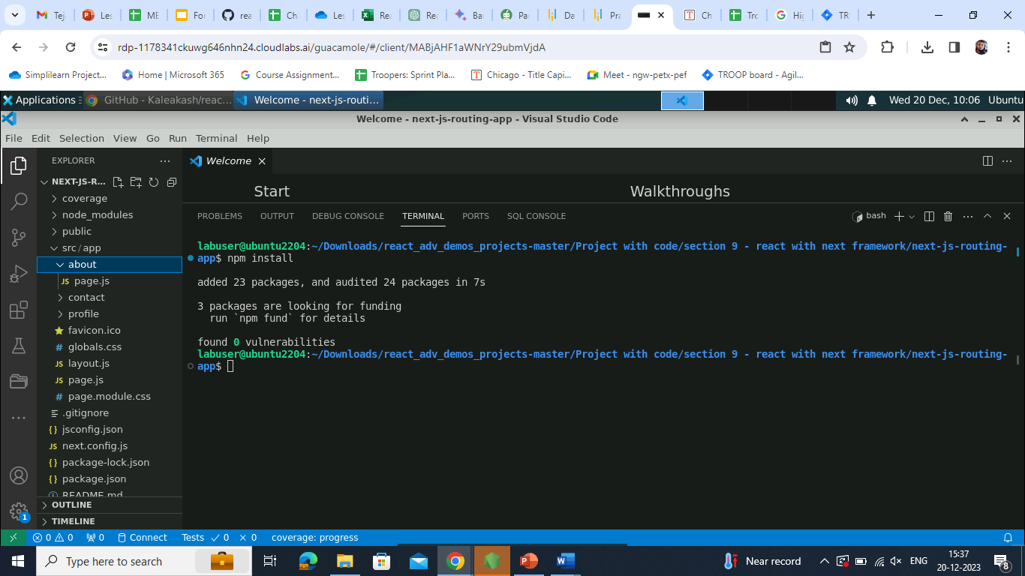

1. Enter the following code inside the **page.js** file:

**export default function AboutUs() {**

**return(**

**<div>**

**<h3>About Us Page</h3>**

**<p>About Us page Description</p>**

**</div>**

**)**

**}**

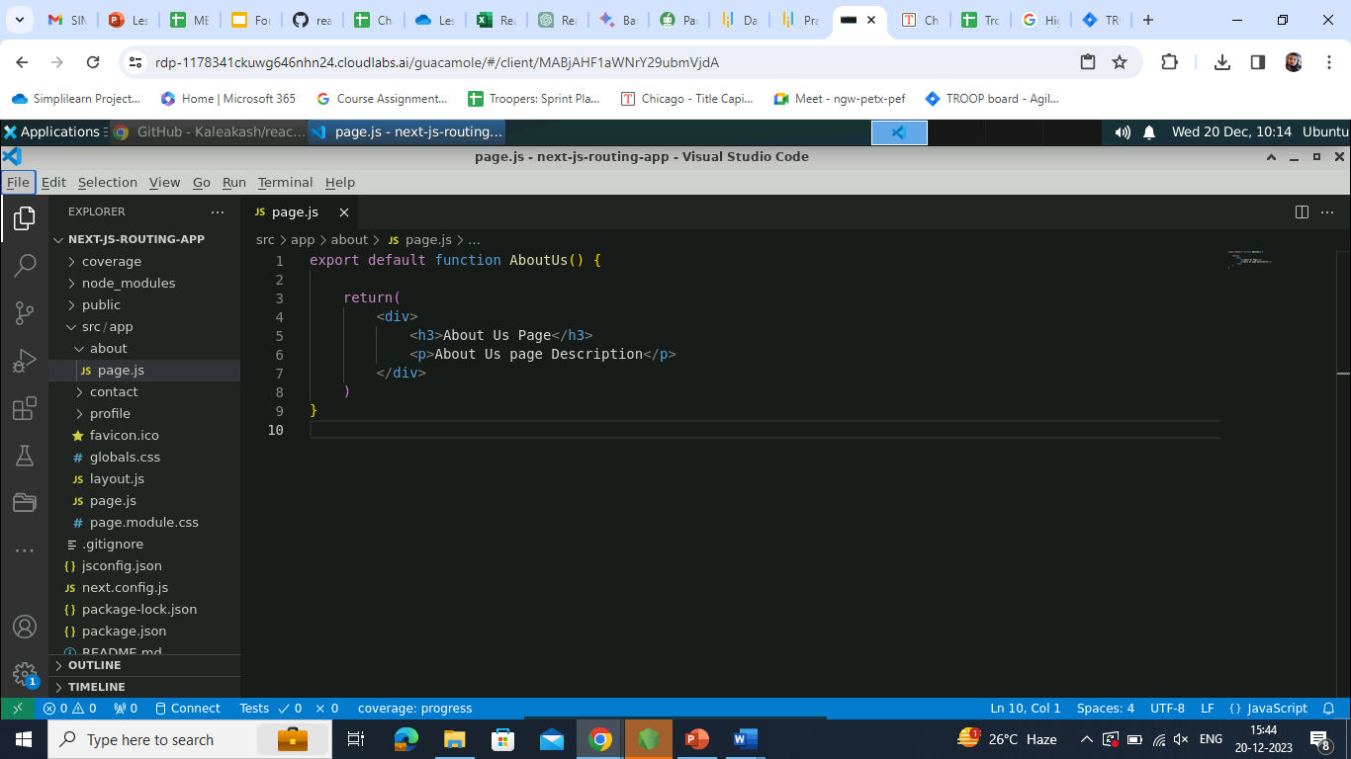

1. Create a **contact** folder and then a **page.js** file inside it

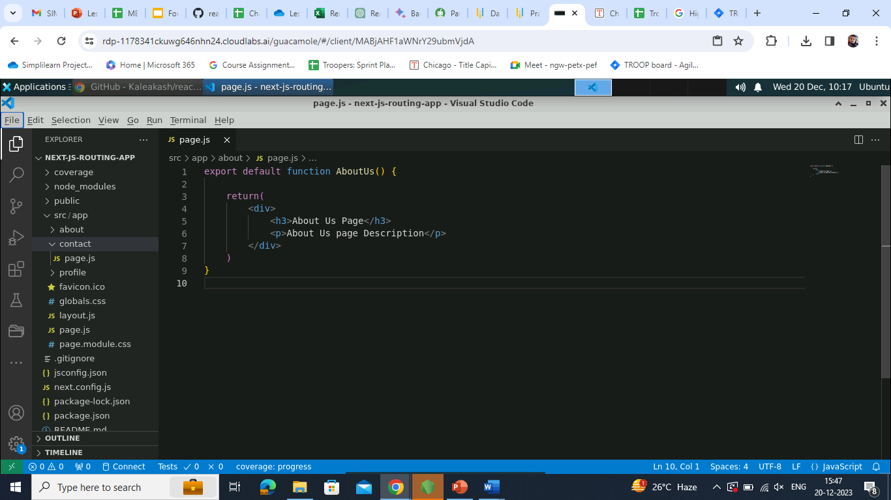

1. Enter the following code inside the **page.js** file:

**export default function ContactUs() {**

**return(**

**<div>**

**<h3>Contact Us Page</h3>**

**<p>Contact Us page Description</p>**

**</div>**

**)**

**}**

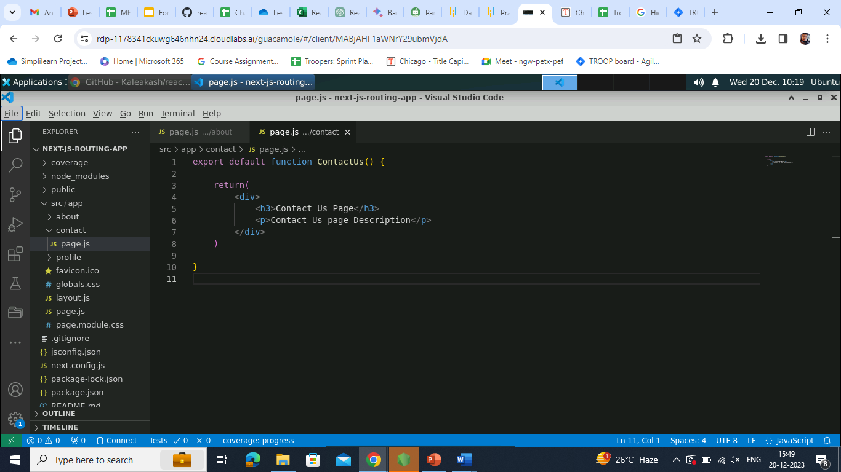

1. Create a **profile** folder and then a subfolder as **adminprofile**

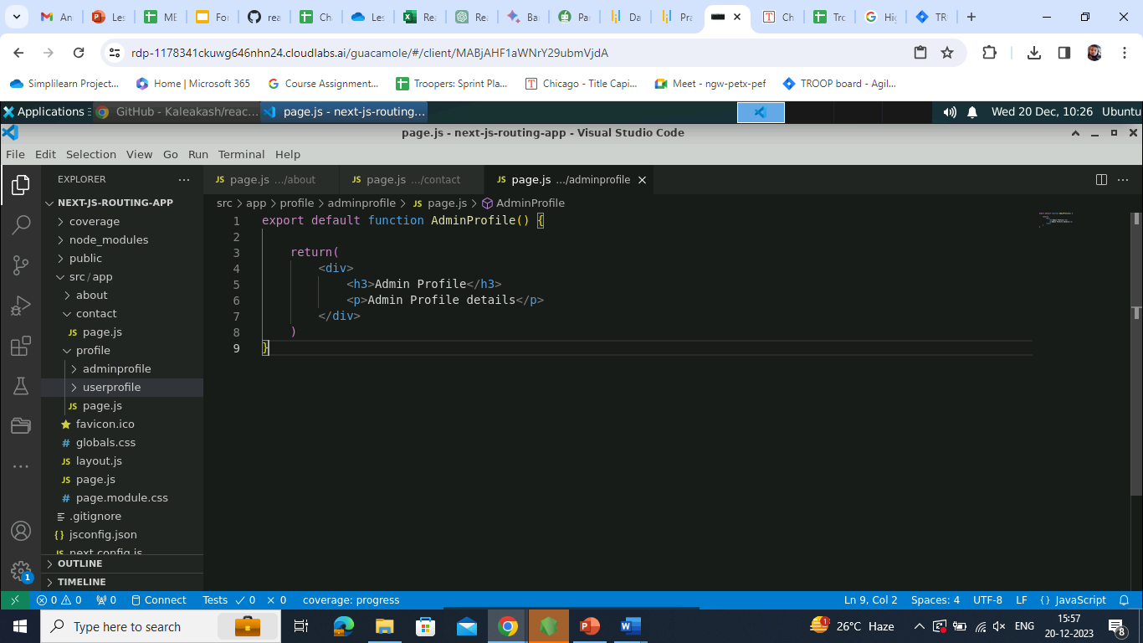

1. Create a **page.js** file inside the **adminprofile** folder

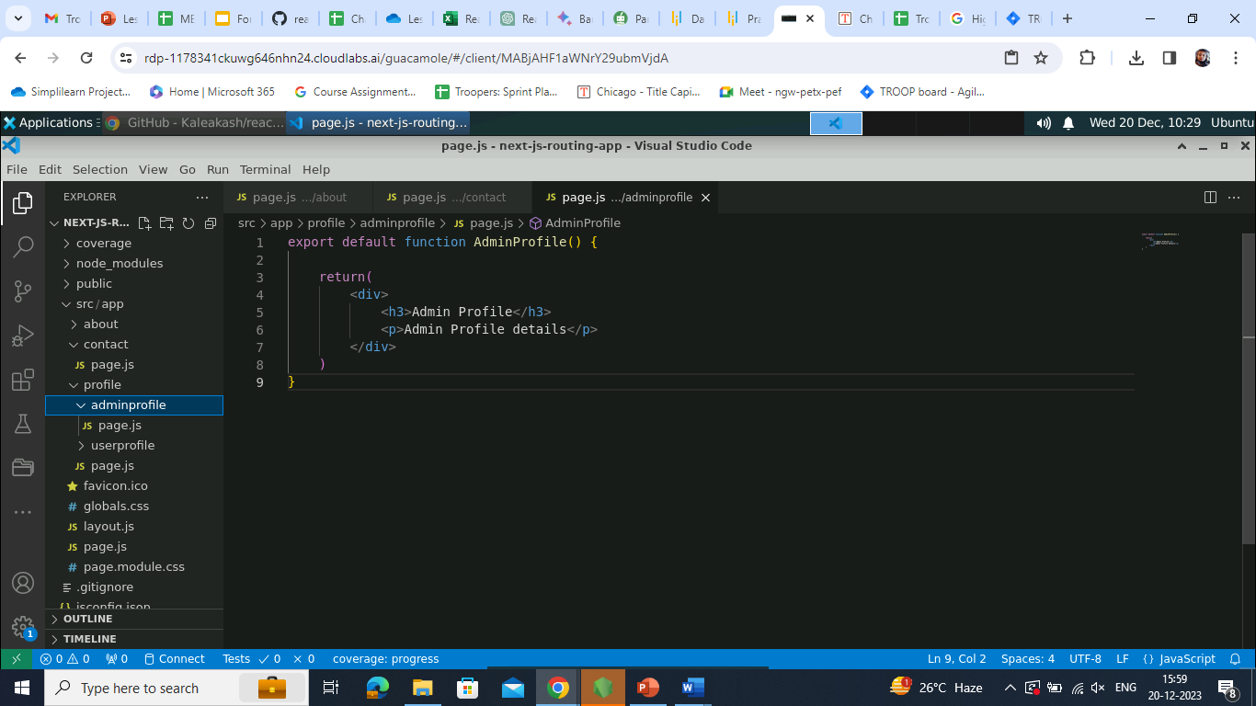

1. Enter the following code inside the **page.js** file:

**export default function AdminProfile() {**

**return(**

**<div>**

**<h3>Admin Profile</h3>**

**<p>Admin Profile details</p>**

**</div>**

**)**

**}**

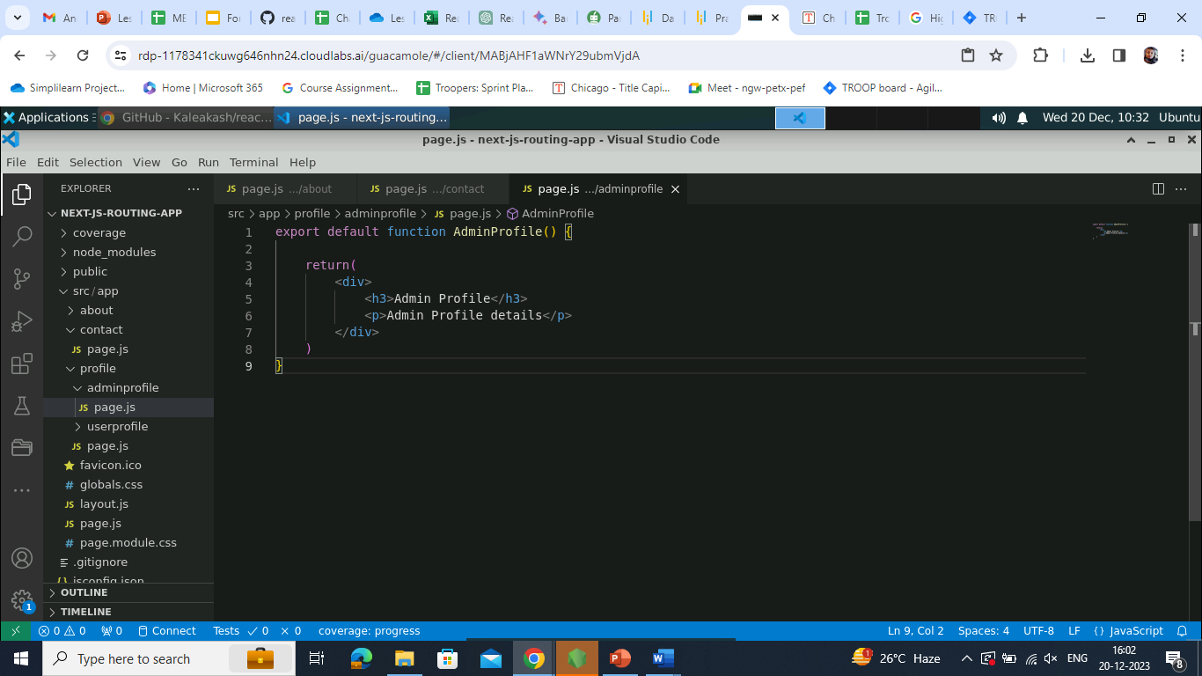

1. Now, create a **userprofile** subfolder that contains the **page.js** file (considered as nested routing)

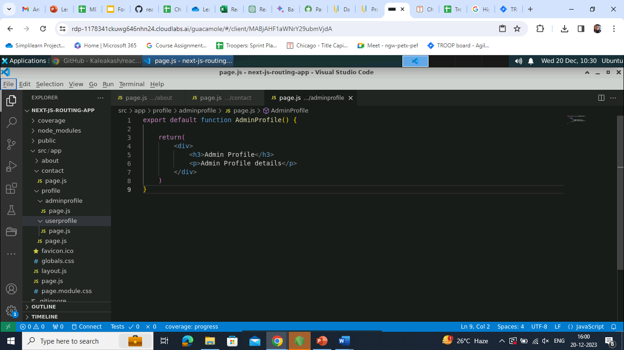

1. Enter the following code inside the **page.js** file:

**export default function UserProfile() {**

**return(**

**<div>**

**<h3>User Profile</h3>**

**<p>User Profile details</p>**

**</div>**

**)**

**}**

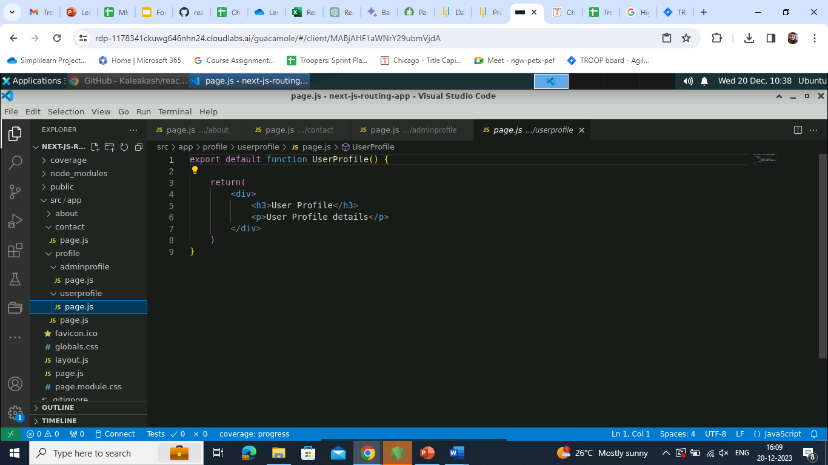

1. In the **page.js** file (inside the **src/app** folder), write the following code:

**import Image from 'next/image'**

**import styles from './page.module.css'**

**export default function Home() {**

**return (**

**<main className={styles.main}>**

**<div>This is next routing example</div>**

**</main>**

**)**

**}**

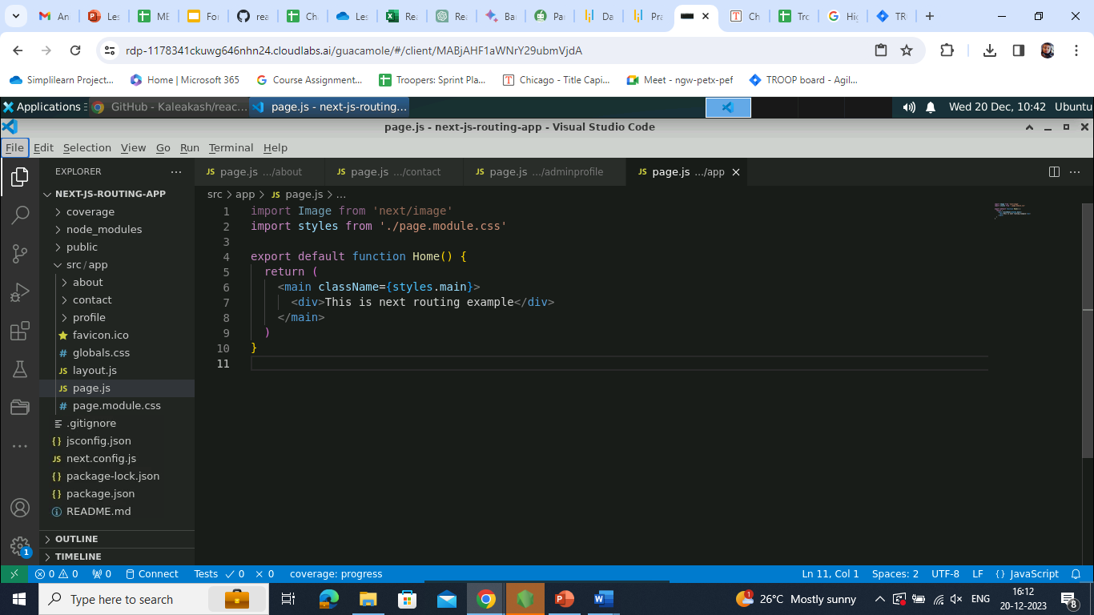

**Step 3: Run the application**

1. Open the terminal inside the project and run the application using the following command:

**npm run dev**

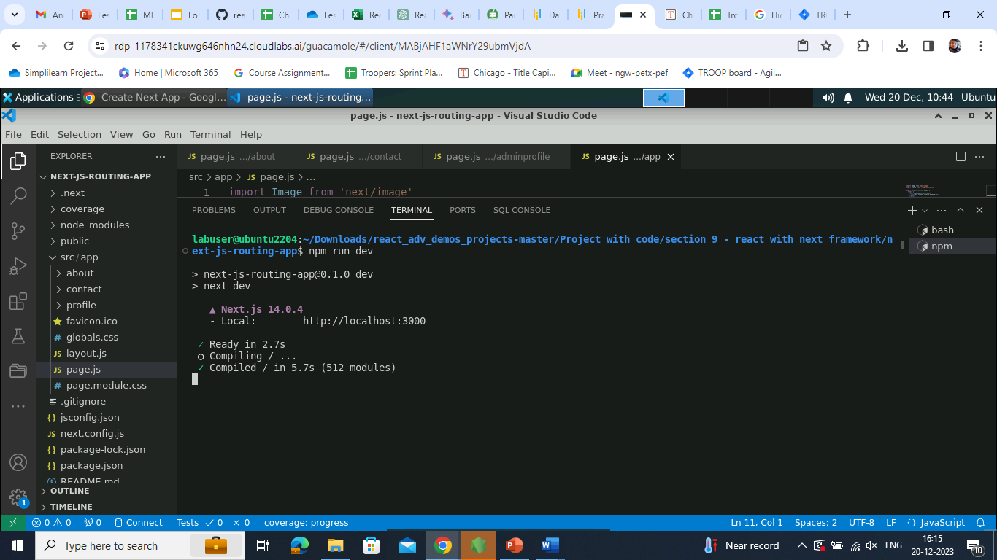

1. Open the following URL:

**<http://localhost:3000>**

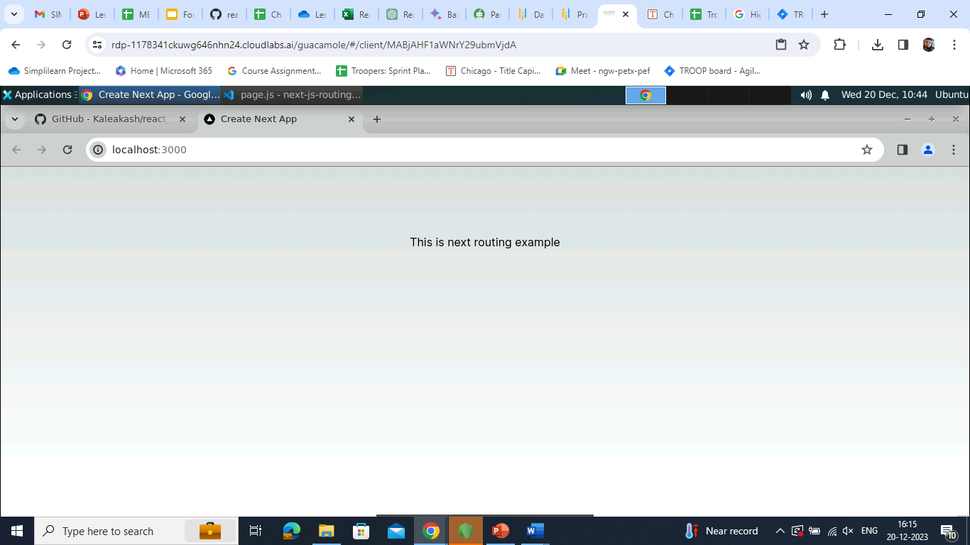

1. Now, include the **about** folder in the URL section (after **http://localhost:3000**)

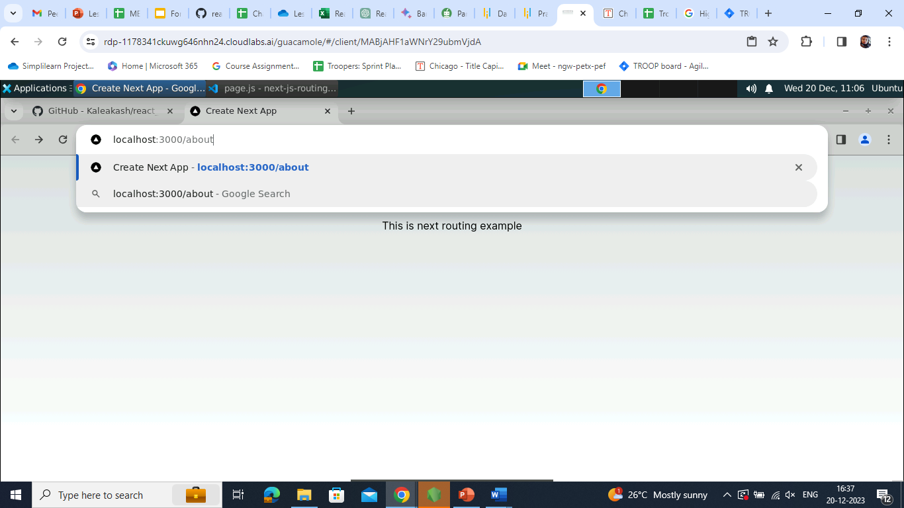

Given below is the interface of the **About Us Page**:

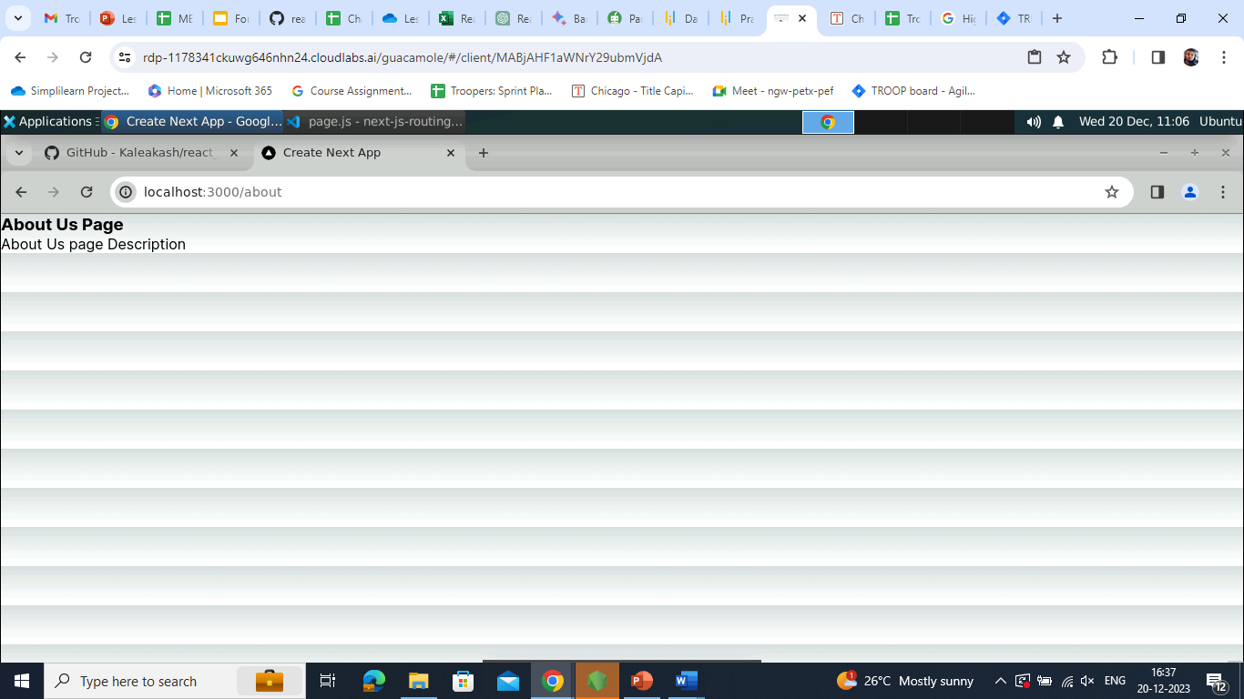

1. Now, include the **contact** folder in the URL section (**http://localhost:3000**)

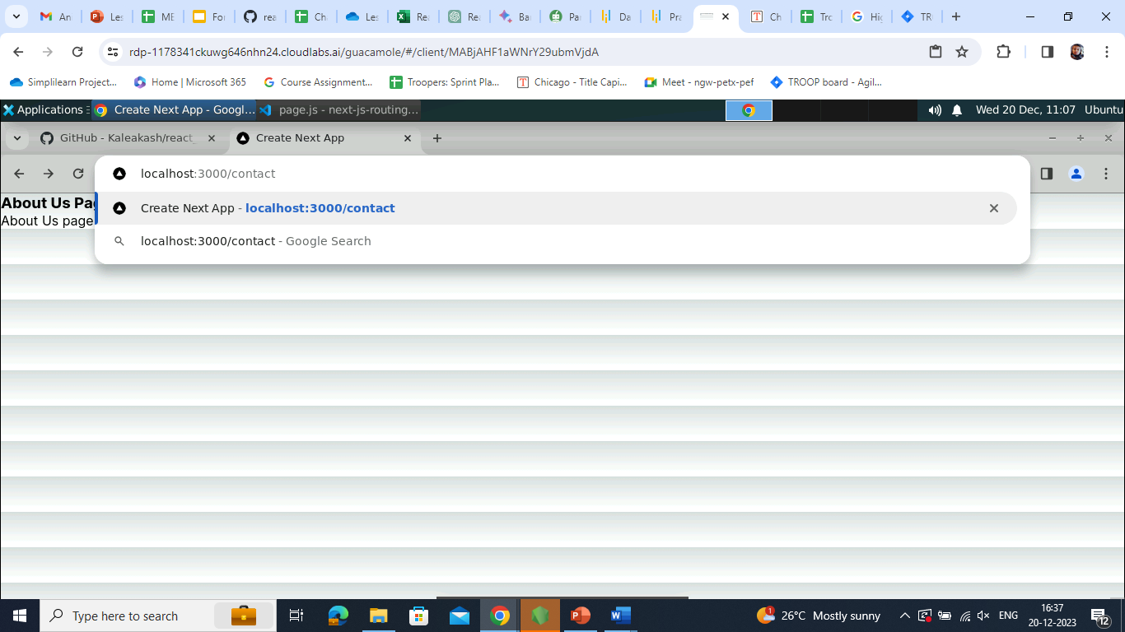

Given below is the interface of the **Contact Us Page**:

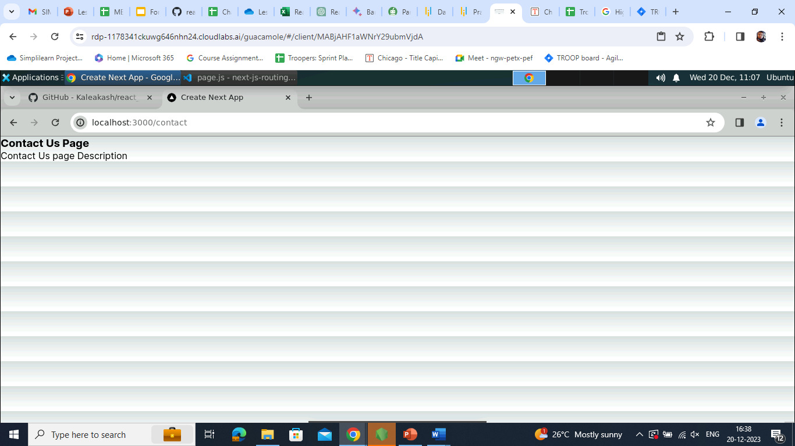

1. Now, include the **adminprofile** folder in the URL section (**http://localhost:3000**)

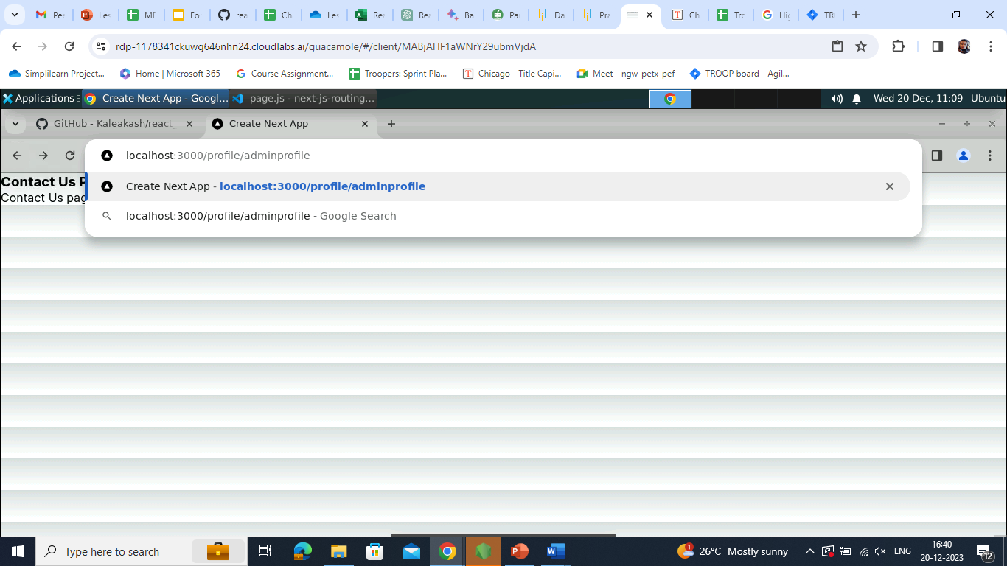

Given below is the interface of the **Admin Profile** page:

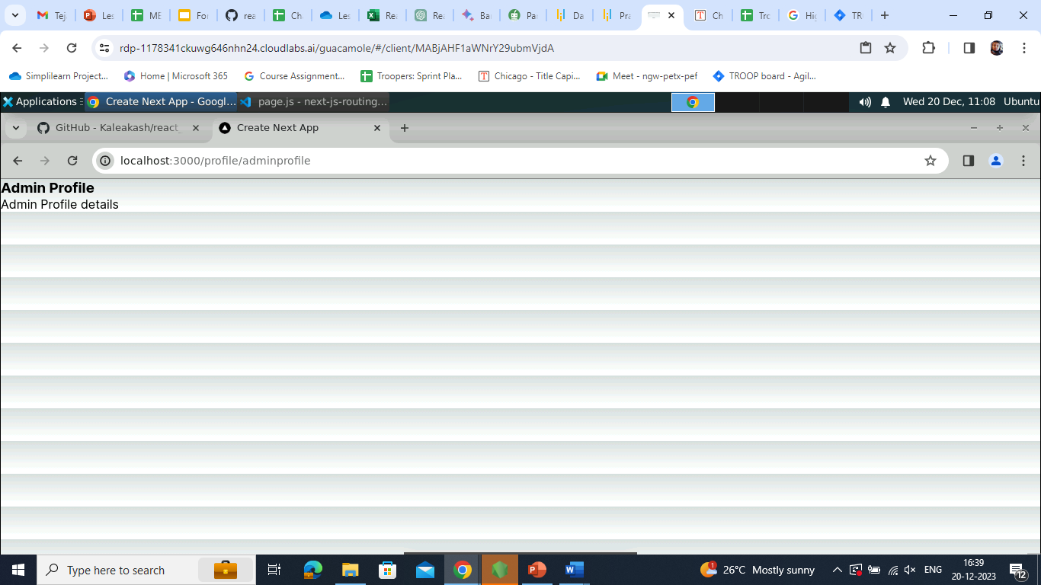

With this, you have successfully created the Next.js server-side routing application based on the path provided by the browser.